Prince of Persia 2 DAT Differences
a comparison of IR, 1.0 and 1.1

June 7, 2014

Contents

Preamble 2
License 2
1. Differences in non-DAT files 3
2. Only in certain versions 4
2.1 Only in IR 4
2.2 Only in 1.0/1.1 4
3. Differences between IR and 1.0/1.1 5
3.1 Graphics 5
3.2 PCS 7
3.3 Binaries 8
3.4 Midi 8
3.5 Palettes 8
4. Level layout differences (Prince.dat) 9
4.1 Level 3 9
4.2 Level 4 11
4.3 Level 5 13
4.4 Level 6 15
4.5 Level 7 16
4.6 Level 8 18
4.7 Level 9 22
4.8 Level 10 23
4.9 Level 11 25
4.10 Level 12 26
4.11 Level 13 30
4.12 Level 14 32
4.13 Level 22 33
Credits 34

Preamble

This document describes the differences (according to, among other things, PR v1.3.1-prerelease) between the DAT files that are being supplied with Prince of Persia 2 versions IR (initial release), 1.0 and 1.1, as they can be found in Andrew's The Ultimate Collection v1.3.

This is only the first version of this document, so there is a lot of room for improvement. In case you find a mistake or have a suggestion, please let us know.

A document similar to this also exists for Prince of Persia 1. It can be downloaded at: http://www.popot.org/documentation.php?doc=PoP1_DAT_Differences

License

Copyright © 2014 Prince of Persia modding community

Permission is granted to copy, distribute and/or modify this document under the terms of the GNU Free Documentation License, Version 1.3 or any later version published by the Free Software Foundation; with no Invariant Sections, no Front-Cover Texts, and no Back-Cover Texts.

1. Differences in non-DAT files

- Different in all versions: Prince.exe, Setup.exe, Setup.cfg
- Changed when moving from IR to 1.0: Snddrvrs/Dmvision.drv
- Removed when moving from 1.0 to 1.1: Tandysnd.dat, Fragsnd.dat, and ten files from the Snddrvrs/ directory (Ddisney.drv, Dmvision.drv, Dps1.drv, Dsblast.drv, Dtandy.drv, Madlib.drv, Mmvision.drv, Mps1.drv, Msblast.drv, Mtandy.drv).

2. Only in certain versions

2.1 Only in IR

- Fragsnd.dat: _snd30500.bin
- Ibmsnd.dat: _snd10267.pcs
- Midisnd.dat: _snd10267.mid (Happy1.mff)
- Nis3vc.dat: _snd31021.mid (Throne4.gmf)
- Nisibm.dat: _snd31021.pcs
- Nismidi.dat: _snd31021.mid (Throne4.mff)
- Rooftops.dat: shap04166.bmp, shap04167.bmp



- Tandysnd.dat: _snd10267.mid (Happy1.gmf)

2.2 Only in 1.0/1.1

- Ibmsnd.dat: _snd10254.pcs, _snd10255.pcs
- Midisnd.dat: _snd10198.mid (JGrows.mff), _snd10199.mid (JFight.mff), _snd10255.mid (Throne4.mff)
- Prince.dat: txt401012.bin, txt408011.bin
- Tandysnd.dat: _snd10198.mid (JGrows.gmf), _snd10199.mid (JFight.gmf), _snd10255.mid (Throne4.gmf)

3. Differences between IR and 1.0/1.1

3.1 Graphics

Caverns.dat: shap03805.bmp

Final.dat: shap04050.bmp, shap04125.bmp, shap04150.bmp, shap04153.bmp, shap25345.bmp

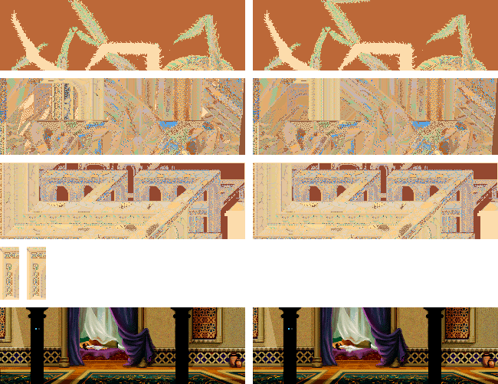

Differences (from top to bottom): extra spider leg part at the top, front 'pillar' moved to the left (plus some smoother lines), middle right line (very minor), top right pixels (very minor), the princess has a bigger and smoother gown.

Prince.dat: shap01011.bmp, shap01246.bmp



Differences (for both): one black pixel changed to gray.

Rooftops.dat: shap04158.bmp, shap04159.bmp, shap04160.bmp, shap04161.bmp, shap04172.bmp

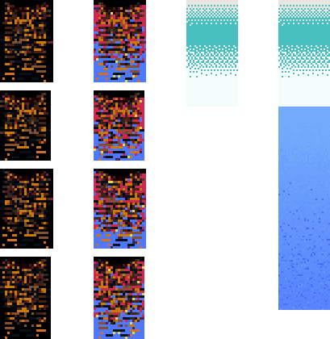

Trans.dat: shap04210.bmp, shap04211.bmp, shap04212.bmp, shap04213.bmp

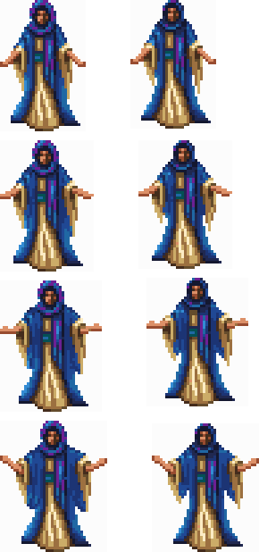

Differences (for all sets): the robes are less thick.

3.2 PCS

- Ibmsnd.dat: _snd10023.pcs, _snd10024.pcs, _snd10058.pcs, _snd10253.pcs
- Nisibm.dat: _snd30000.pcs

3.3 Binaries

- Final.dat: cust04150.bin, cust04175.bin
- Nis.dat: strl26000.bin
- Prince.dat: ____00025.bin, ____00026.bin, ____00027.bin, txt400010.bin, txt401011.bin
- Rooftops.dat: cust04375.bin, cust04450.bin
- Sequence.dat: seqs00012.bin, seqs00022.bin, seqs00053.bin, seqs00117.bin, seqs00121.bin, seqs00169.bin, seqs00191.bin, seqs00192.bin, seqs00193.bin, seqs00194.bin, seqs00195.bin, seqs00197.bin, seqs00209.bin, seqs00243.bin

3.4 Midi

- Midisnd.dat: _snd10027.mid (OpenDoor.mff), _snd10028.mid (LvCav.mff), _snd10029.mid (LvRuins.mff), _snd10030.mid (LvTemple.mff), _snd10149.mid (SnakKill.mff), _snd10151.mid (FindSwd.mff), _snd10154.mid (InvOff.mff), _snd10196.mid (JPoof.mff)
- Nis3vc.dat: _snd25009.mid (ToTower.gmf), _snd30000.mid (Happy1.gmf), _snd30010.mid (Happy2.gmf)
- Nismidi.dat: _snd25015.mid (Opening6.mff), _snd26019.mid (Tragic.mff), _snd28100.mid (ABShip1.mff), _snd30000.mid (Happy1.mff)
- Tandysnd.dat: _snd10028.mid (LvCav.gmf), _snd10034.mid (FlyinRug.gmf), _snd10265.mid (LoseSwd.gmf), _snd10266.mid (ThroFire.gmf), _snd10268.mid (ChessRm.gmf), _snd10269.mid (Spider.gmf), _snd10270.mid (Crystal.gmf), _snd10271.mid (JafPoof.gmf), _snd10272.mid (Shadow.gmf)

3.5 Palettes

- Trans.dat: palt04211.pal (fourteen lines from 0 0 0 to values) and palt25010.pal (various changes)

4. Level layout differences (Prince.dat)

There are no differences between 1.0 and 1.1. This chapter (thus) lists the differences between IR and 1.0. Tile numbers start at 0. Changes that had a notable/interesting impact have been marked with red comments.

4.1 Level 3

Room 1, tile 20: 19/5 0 0 0 -> 19/4 0 0 0 (flame, same in apoplexy v2.2b)
Room 3, tile 27: 19/8 0 0 0 -> 19/6 0 0 0 (flame, same in apoplexy v2.2b)
Room 4, tile 20: 19/3 3 0 0 -> 19/1 3 0 0 (flame, same in apoplexy v2.2b)
Room 5, tile 28: 19/4 0 0 0 -> 19/1 0 0 0 (flame, same in apoplexy v2.2b)
Room 7, tile 3: 10/37 0 0 0 -> 10/39 0 0 0 (red potion, same in apoplexy v2.2b)
Room 7, tile 4: 19/4 0 0 0 -> 19/2 0 0 0 (flame, same in apoplexy v2.2b)
Room 9, tile 16: 10/37 24 0 0 -> 10/52 24 0 0 (potion, same in apoplexy v2.2b)
Room 9, tile 23: 19/1 16 0 0 -> 19/2 16 0 0 (flame, same in apoplexy v2.2b)
Room 10, tile 15: 1/0 0 0 0 -> 34/81 0 0 0 (raise-drop closer to lava in 1.0; makes it more difficult)

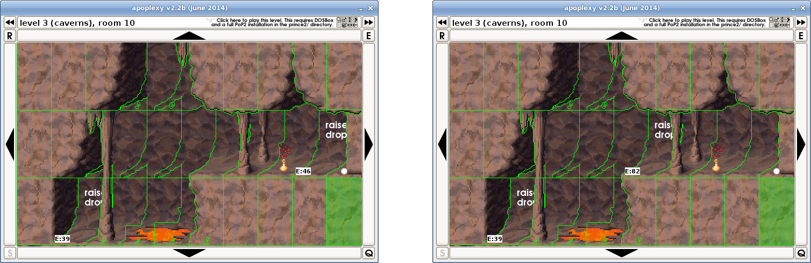

Room 10, tile 17: 10/69 0 0 0 -> 10/88 0 0 0 (life potion, same in apoplexy v2.2b)
Room 10, tile 18: 34/45 0 0 0 -> 1/0 0 0 0 (raise-drop was here)
Room 13, tile 17: 19/3 0 0 0 -> 19/0 0 0 0 (flame, same in apoplexy v2.2b)
Room 13, tile 20: 19/6 1 0 0 -> 19/8 1 0 0 (flame, same in apoplexy v2.2b)
Room 14, tile 27: 19/0 0 0 0 -> 19/1 0 0 0 (flame, same in apoplexy v2.2b)
Room 15, tile 20: 19/1 0 0 0 -> 19/3 0 0 0 (flame, same in apoplexy v2.2b)
Room 16, tile 15: 19/3 0 0 0 -> 19/6 0 0 0 (flame, same in apoplexy v2.2b)
Room 16, tile 18: 19/8 0 0 0 -> 19/5 0 0 0 (flame, same in apoplexy v2.2b)
Room 17, tile 20: 19/8 0 0 0 -> 19/7 0 0 0 (flame, same in apoplexy v2.2b)
Room 17, tile 28: 19/6 0 0 0 -> 19/2 0 0 0 (flame, same in apoplexy v2.2b)
Room 20, tile 8: 10/65 0 0 0 -> 10/72 0 0 0 (life potion, same in apoplexy v2.2b)
Room 20, tile 21: 19/7 0 0 0 -> 19/6 0 0 0 (flame, same in apoplexy v2.2b)
Room 21, tile 26: 19/3 0 0 0 -> 19/5 0 0 0 (flame, same in apoplexy v2.2b)
Room 22, tile 8: 19/5 0 0 0 -> 19/3 0 0 0 (flame, same in apoplexy v2.2b)
Room 22, tile 11: 19/7 0 0 0 -> 19/4 0 0 0 (flame, same in apoplexy v2.2b)
Room 23, tile 7: 19/1 0 0 0 -> 19/0 0 0 0 (flame, same in apoplexy v2.2b)
Room 23, tile 8: 19/0 0 0 0 -> 19/4 0 0 0 (flame, same in apoplexy v2.2b)
Room 24, tile 2: 19/6 0 0 0 -> 19/8 0 0 0 (flame, same in apoplexy v2.2b)
Room 25, tile 7: 19/8 0 0 0 -> 19/4 0 0 0 (flame, same in apoplexy v2.2b)
Room 26, tile 5: 19/8 7 0 0 -> 19/5 7 0 0 (flame, same in apoplexy v2.2b)
Room 26, tile 26: 10/55 0 0 0 -> 10/38 0 0 0 (red potion, same in apoplexy v2.2b)
Room 27, tile 21: 19/2 0 0 0 -> 19/5 0 0 0 (flame, same in apoplexy v2.2b)
Room 28, tile 26: 19/0 0 0 0 -> 19/6 0 0 0 (flame, same in apoplexy v2.2b)
Room 30, tile 26: 19/4 0 0 0 -> 19/6 0 0 0 (flame, same in apoplexy v2.2b)
Room 31, tile 0: 19/3 0 0 0 -> 19/2 0 0 0 (flame, same in apoplexy v2.2b)
Event 46 changes room: 10, loc: 19. (t: 0, l: 253, r: 253) -> room: 1, loc: 19. (t: 0, l: 253, r: 253)
Event 82 changes room: 1, loc: 0. (t: 255, l: 255, r: 255) -> room: 10, loc: 19. (t: 0, l: 253, r: 253)
Static guard 1: 21|176|0|0|0|119|0|0|0|1|0|82|117|110|45|2|105|255|255|0|0|0|1 -> 21|176|0|0|0|119|0|0|0|1|0|82|117|110|45|2|105|255|255|0|0|0|3

4.2 Level 4

Room 1, tile 22: 19/6 0 0 0 -> 19/2 0 0 0 (flame, same in apoplexy v2.2b)
Room 1, tile 23: 19/5 0 0 0 -> 19/6 0 0 0 (flame, same in apoplexy v2.2b)
Room 2, tile 28: 19/1 0 0 0 -> 19/4 0 0 0 (flame, same in apoplexy v2.2b)
Room 3, tile 11: 19/8 0 0 0 -> 19/5 0 0 0 (flame, same in apoplexy v2.2b)
Room 3, tile 25: 10/48 0 0 0 -> 10/38 0 0 0 (red potion, same in apoplexy v2.2b)
Room 5, tile 26: 10/37 0 0 0 -> 10/53 0 0 0 (red potion, same in apoplexy v2.2b)
Room 6, tile 2: 10/98 0 0 0 -> 10/114 0 0 0 (float potion, same in apoplexy v2.2b)
Room 7, tile 13: 19/3 0 0 0 -> 19/7 0 0 0 (flame, same in apoplexy v2.2b)
Room 7, tile 28: 19/1 0 0 0 -> 19/3 0 0 0 (flame, same in apoplexy v2.2b)
Room 9, tile 15: 10/57 0 0 0 -> 10/43 0 0 0 (red potion, same in apoplexy v2.2b)
Room 10, tile 28: 19/1 0 0 0 -> 19/8 0 0 0 (flame, same in apoplexy v2.2b)
Room 11, tile 24: 19/2 1 0 0 -> 19/3 1 0 0 (flame, same in apoplexy v2.2b)
Room 11, tile 26: 19/1 1 0 0 -> 19/8 1 0 0 (flame, same in apoplexy v2.2b)
Room 11, tile 27: 10/68 2 0 0 -> 10/74 2 0 0 (life potion, same in apoplexy v2.2b)
Room 13, tile 20: 19/5 0 0 0 -> 19/6 0 0 0 (flame, same in apoplexy v2.2b)
Room 13, tile 26: 19/0 0 0 0 -> 19/6 0 0 0 (flame, same in apoplexy v2.2b)
Room 13, tile 27: 10/34 0 0 0 -> 10/55 0 0 0 (red potion, same in apoplexy v2.2b)
Room 14, tile 15: 10/161 0 0 0 -> 10/187 0 0 0 (purple potion, same in apoplexy v2.2b)
Room 15, tile 15: 19/7 0 0 0 -> 19/3 0 0 0 (flame, same in apoplexy v2.2b)
Room 15, tile 21: 19/3 0 0 0 -> 19/7 0 0 0 (flame, same in apoplexy v2.2b)
Room 16, tile 5: 19/4 0 0 0 -> 19/0 0 0 0 (flame, same in apoplexy v2.2b)
Room 16, tile 7: 19/3 0 0 0 -> 19/7 0 0 0 (flame, same in apoplexy v2.2b)
Room 17, tile 18: 19/7 0 0 0 -> 19/6 0 0 0 (flame, same in apoplexy v2.2b)
Room 18, tile 13: 19/6 0 0 0 -> 19/8 0 0 0 (flame, same in apoplexy v2.2b)
Room 19, tile 1: 10/55 0 0 0 -> 10/57 0 0 0 (red potion, same in apoplexy v2.2b)
Room 19, tile 2: 19/0 0 0 0 -> 19/4 0 0 0 (flame, same in apoplexy v2.2b)
Room 19, tile 8: 10/57 0 0 0 -> 10/42 0 0 0 (red potion, same in apoplexy v2.2b)
Room 20, tile 28: 19/3 0 0 0 -> 19/4 0 0 0 (flame, same in apoplexy v2.2b)
Room 21, tile 23: 19/3 0 0 0 -> 19/2 0 0 0 (flame, same in apoplexy v2.2b)
Room 21, tile 27: 19/6 0 0 0 -> 19/7 0 0 0 (flame, same in apoplexy v2.2b)
Room 22, tile 22: 19/7 0 0 0 -> 19/3 0 0 0 (flame, same in apoplexy v2.2b)
Room 22, tile 25: 19/2 0 0 0 -> 19/6 0 0 0 (flame, same in apoplexy v2.2b)
Room 22, tile 26: 19/7 0 0 0 -> 19/5 0 0 0 (flame, same in apoplexy v2.2b)
Room 22, tile 28: 10/35 0 0 0 -> 10/41 0 0 0 (red potion, same in apoplexy v2.2b)
Room 23, tile 28: 19/5 0 0 0 -> 19/3 0 0 0 (flame, same in apoplexy v2.2b)
Room 24, tile 23: 19/6 0 0 0 -> 19/3 0 0 0 (flame, same in apoplexy v2.2b)
Room 24, tile 28: 19/7 0 0 0 -> 19/1 0 0 0 (flame, same in apoplexy v2.2b)
Room 25, tile 21: 19/6 0 0 0 -> 19/4 0 0 0 (flame, same in apoplexy v2.2b)
Room 25, tile 27: 19/6 0 0 0 -> 19/1 0 0 0 (flame, same in apoplexy v2.2b)
Room 25, tile 28: 19/7 0 0 0 -> 19/2 0 0 0 (flame, same in apoplexy v2.2b)
Room 26, tile 21: 19/2 0 0 0 -> 19/6 0 0 0 (flame, same in apoplexy v2.2b)
Room 26, tile 23: 19/7 0 0 0 -> 19/1 0 0 0 (flame, same in apoplexy v2.2b)
Room 26, tile 25: 10/49 0 0 0 -> 10/33 0 0 0 (red potion, same in apoplexy v2.2b)
Room 27, tile 22: 19/7 0 0 0 -> 19/6 0 0 0 (flame, same in apoplexy v2.2b)
Room 28, tile 21: 19/2 0 0 0 -> 19/4 0 0 0 (flame, same in apoplexy v2.2b)
Room 28, tile 26: 19/2 0 0 0 -> 19/3 0 0 0 (flame, same in apoplexy v2.2b)
Room 28, tile 28: 19/8 0 0 0 -> 19/3 0 0 0 (flame, same in apoplexy v2.2b)
Room 29, tile 25: 10/179 6 0 0 -> 10/173 6 0 0 (purple potion, same in apoplexy v2.2b)
Room 29, tile 27: 10/52 4 0 0 -> 10/43 2 0 0 (red potion, same in apoplexy v2.2b)
Static guards in room 5: 1 -> 0
Static guard 1: 29|128|0|0|5|112|0|0|0|1|0|0|0|0|0|2|5|0|0|0|0|0|0 -> (none)
Static guards in room 23: 0 -> 1
Static guard 1: (none) -> 29|192|1|0|5|112|0|0|0|1|0|0|0|0|0|2|5|0|0|0|0|0|0

4.3 Level 5

Room 1, tile 22: 19/7 0 0 0 -> 19/1 0 0 0 (flame, same in apoplexy v2.2b)
Room 1, tile 25: 19/7 0 0 0 -> 19/4 0 0 0 (flame, same in apoplexy v2.2b)
Room 2, tile 8: 11/0 24 0 0 -> 20/5 2 0 0 (loose tile above raise-drop removed in 1.0)

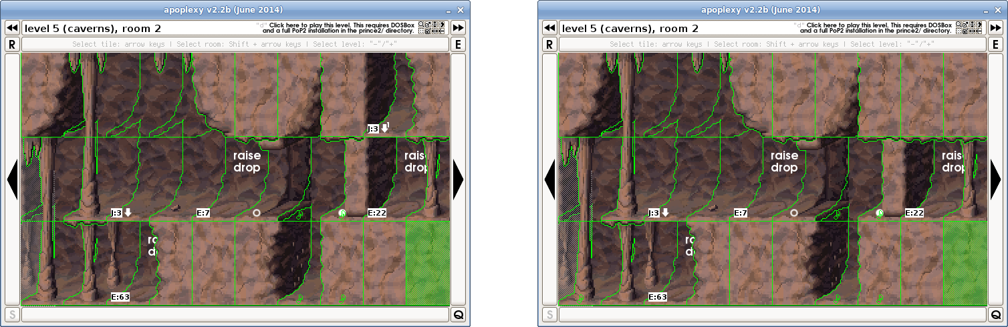

Room 2, tile 9: 20/2 1 0 0 -> 20/10 2 0 0 (wall, straight in 1.0)
Room 4, tile 7: 19/1 0 0 0 -> 19/7 0 0 0 (flame, same in apoplexy v2.2b)
Room 5, tile 6: 10/39 0 0 0 -> 10/45 0 0 0 (red potion, same in apoplexy v2.2b)
Room 6, tile 5: 10/89 0 0 0 -> 10/84 0 0 0 (life potion, same in apoplexy v2.2b)
Room 6, tile 14: 19/7 0 0 0 -> 19/3 0 0 0 (flame, same in apoplexy v2.2b)
Room 6, tile 17: 19/0 4 0 0 -> 19/2 4 0 0 (flame, same in apoplexy v2.2b)
Room 7, tile 0: 19/6 8 0 0 -> 19/3 8 0 0 (flame, same in apoplexy v2.2b)
Room 7, tile 14: 19/6 0 0 0 -> 19/7 0 0 0 (flame, same in apoplexy v2.2b)
Room 7, tile 18: 10/53 0 0 0 -> 10/52 0 0 (red potion, same in apoplexy v2.2b)
Room 8, tile 6: 10/42 0 0 0 -> 10/36 0 0 0 (red potion, same in apoplexy v2.2b)
Room 9, tile 14: 19/3 0 0 0 -> 19/0 0 0 0 (flame, same in apoplexy v2.2b)
Room 9, tile 18: 19/6 0 0 0 -> 19/7 0 0 0 (flame, same in apoplexy v2.2b)
Room 11, tile 1: 19/6 0 0 0 -> 19/5 0 0 0 (flame, same in apoplexy v2.2b)
Room 11, tile 18: 19/8 0 0 0 -> 19/1 0 0 0 (flame, same in apoplexy v2.2b)
Room 12, tile 10: 19/4 0 0 0 -> 19/2 0 0 0 (flame, same in apoplexy v2.2b)
Room 13, tile 18: 19/5 0 0 0 -> 19/3 0 0 0 (flame, same in apoplexy v2.2b)
Room 14, tile 10: 19/2 0 0 0 -> 19/6 0 0 0 (flame, same in apoplexy v2.2b)
Room 14, tile 26: 10/56 0 0 0 -> 10/42 0 0 0 (red potion, same in apoplexy v2.2b)
Room 15, tile 10: 19/1 0 0 0 -> 19/8 0 0 0 (flame, same in apoplexy v2.2b)
Room 16, tile 20: 19/5 0 0 0 -> 19/8 0 0 0 (flame, same in apoplexy v2.2b)
Room 20, tile 1: 19/2 2 0 0 -> 19/4 2 0 0 (flame, same in apoplexy v2.2b)
Room 21, tile 16: 10/50 0 0 0 -> 10/55 0 0 0 (red potion, same in apoplexy v2.2b)
Room 21, tile 25: 10/57 3 0 0 -> 10/55 3 0 0 (red potion, same in apoplexy v2.2b)
Room 22, tile 21: 19/6 0 0 0 -> 19/2 0 0 0 (flame, same in apoplexy v2.2b)
Room 22, tile 24: 10/71 0 0 0 -> 10/66 0 0 0 (life potion, same in apoplexy v2.2b)
Room 22, tile 28: 19/5 0 0 0 -> 19/0 0 0 0 (flame, same in apoplexy v2.2b)
Room 25, tile 8: 19/3 0 0 0 -> 19/7 0 0 0 (flame, same in apoplexy v2.2b)
Static guards in room 7: 0 -> 1
Static guard 1: (none) -> 10|224|1|0|1|63|0|0|0|1|0|0|0|255|0|2|3|1|0|0|0|0|0
Static guards in room 10: 1 -> 0
Static guard 1: 10|160|0|0|1|63|0|0|0|1|0|0|0|255|0|2|3|1|0|0|0|0|0 -> (none)

4.4 Level 6

Room 5, tile 27: 10/90 0 9 1 -> 10/82 0 9 1 (life potion, same in apoplexy v2.2b)
Room 7, tile 28: 10/161 0 9 0 -> 10/180 0 9 0 (purple potion, same in apoplexy v2.2b)
Room 13, tile 28: 10/41 0 6 0 -> 10/45 0 6 0 (red potion, same in apoplexy v2.2b)
Room 25, tile 1: 10/167 0 10 1 -> 10/172 0 10 1 (purple potion, same in apoplexy v2.2b)
Room 25, tile 12: 10/142 0 10 0 -> 10/144 0 10 0 (flip potion, same in apoplexy v2.2b)

4.5 Level 7

Room 2, tile 27: 10/40 0 8 6 -> 10/44 0 8 6 (red potion, same in apoplexy v2.2b)
Room 3, tile 2: 1/1 0 10 1 -> 1/2 0 10 1 (crack on tile removed in 1.0)
Room 3, tile 16: 20/0 0 9 0 -> 20/0 4 9 0 (crack on wall added in 1.0)
Room 3, tile 17: 20/1 0 9 1 -> 20/2 0 9 1 (different wall)
Room 3, tile 18: 20/2 0 0 0 -> 20/5 0 0 0 (different wall)
Room 3, tile 26: 20/6 0 0 0 -> 20/6 7 0 0 (crack on wall added in 1.0)
Room 3, tile 27: 20/4 0 0 0 -> 20/5 0 0 0 (different wall)
Room 3, tile 28: 20/5 0 0 0 -> 20/8 0 0 0 (different wall)
Room 3, tile 29: 20/4 0 10 0 -> 20/5 0 10 0 (different wall)
Room 6, tile 15: 10/51 0 10 1 -> 10/56 0 10 1 (red potion, same in apoplexy v2.2b)
Room 7, tile 18: 10/68 0 10 0 -> 10/67 0 10 0 (life potion, same in apoplexy v2.2b)
Room 8, tile 8: 20/1 6 0 0 -> 20/4 6 0 0 (different wall)
Room 8, tile 9: 20/4 0 9 0 -> 20/5 0 9 0 (different wall)
Room 8, tile 22: 20/2 0 0 0 -> 20/8 3 0 0 (crack on wall added in 1.0)
Room 8, tile 23: 20/0 0 0 0 -> 20/1 0 0 0 (different wall)
Room 8, tile 24: 20/1 0 0 0 -> 20/4 0 0 0 (different wall)
Room 8, tile 25: 20/0 0 0 0 -> 20/2 0 0 0 (different wall)
Room 8, tile 26: 20/4 5 0 0 -> 20/0 5 0 0 (different wall)
Room 8, tile 27: 20/6 0 0 0 -> 20/9 0 0 0 (different wall)
Room 8, tile 28: 20/1 0 0 0 -> 20/4 0 0 0 (different wall)
Room 8, tile 29: 20/0 0 9 0 -> 20/1 0 9 0 (different wall)
Room 11, tile 12: 10/41 0 10 0 -> 10/52 0 10 0 (red potion, same in apoplexy v2.2b)
Room 19, tile 12: 10/56 0 4 0 -> 10/53 0 4 0 (red potion, same in apoplexy v2.2b)
Room 20, tile 13: 1/0 1 4 1 -> 1/0 0 4 1 (crack (rocks) on tile removed in 1.0)
Room 21, tile 22: 20/1 0 0 0 -> 20/2 0 0 0 (different wall)
Room 22, tile 1: 10/48 0 9 1 -> 10/47 0 9 1 (red potion, same in apoplexy v2.2b)
Room 24, tile 3: 10/78 0 9 1 -> 10/88 0 9 1 (life potion, same in apoplexy v2.2b)
Room 29, tile 27: 10/55 0 8 2 -> 10/57 0 8 2 (red potion, same in apoplexy v2.2b)
Room 30, tile 19: 10/45 0 10 1 -> 10/37 0 10 1 (red potion, same in apoplexy v2.2b)
(room 7) Static guard 1: 13|0|1|255|5|130|0|0|0|1|0|0|0|0|0|5|6|0|0|0|0|0|0 -> 16|96|1|255|5|130|0|0|0|1|0|0|0|0|0|5|5|0|0|0|0|0|0 (screaming head starts a bit more to the right in 1.0; makes it easier)

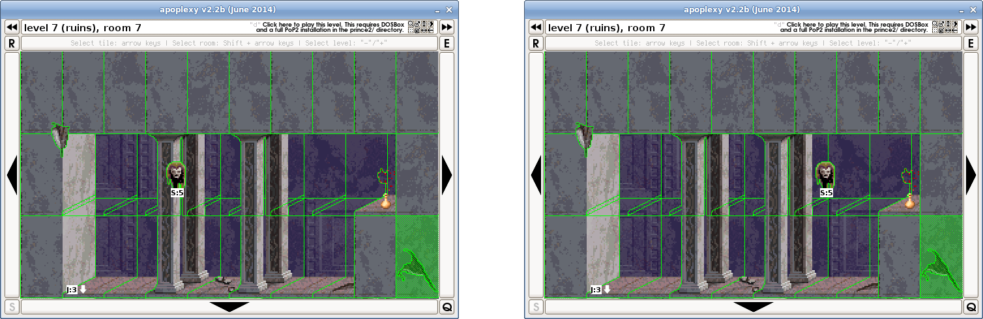

Static guards in room 20: 1 -> 2
Static guard 2: (none) -> 1|240|1|255|3|130|0|0|0|1|1|0|0|0|90|5|4|0|0|0|0|0|0
Static guards in room 22: 1 -> 2
Static guard 2: (none) -> 17|64|0|255|3|130|0|0|0|1|1|0|0|0|0|6|6|0|0|0|0|0|0
Static guards in room 28: 1 -> 0
Static guard 1: 1|176|0|255|3|130|0|0|0|1|0|0|0|0|90|5|4|0|0|0|0|0|0 -> (none)
Static guards in room 30: 1 -> 0
Static guard 1: 17|128|1|255|3|130|0|0|0|1|0|0|0|0|0|6|6|0|0|0|0|0|0 -> (none)

4.6 Level 8

Room 1, tile 0: 1/3 0 9 0 -> 0/3 0 9 0 (a tile removed in 1.0)
Room 1, tile 1: 1/1 0 9 1 -> 1/2 0 9 1 (crack on tile removed in 1.0)
Room 2, tile 8: 20/0 0 9 0 -> 20/4 0 9 0 (different wall right (not visible))
Room 2, tile 9: 20/0 0 9 1 -> 20/2 0 9 1 (different wall)
Room 2, tile 18: 20/0 0 9 0 -> 20/8 0 9 0 (different wall right (not visible))
Room 2, tile 19: 20/0 0 9 1 -> 20/1 0 9 1 (different wall)
Room 3, tile 25: 20/0 0 9 1 -> 20/1 0 9 1 (different wall)
Room 3, tile 26: 20/0 0 9 0 -> 20/8 3 9 0 (crack on wall added in 1.0)
Room 3, tile 27: 20/0 0 9 1 -> 20/1 0 9 1 (different wall)
Room 3, tile 29: 20/0 0 9 1 -> 20/1 0 9 1 (different wall)
Room 6, tile 9: 11/0 0 10 1 -> 0/0 0 10 1 (loose tile removed in 1.0; makes it more difficult)
Room 6, tile 15: 20/0 0 10 1 -> 20/2 0 10 1 (different wall)
Room 8, tile 4: 20/0 0 9 0 -> 20/1 0 9 0 (different wall)
Room 8, tile 5: 20/0 0 9 1 -> 20/1 0 9 1 (different wall)
Room 8, tile 6: 20/0 0 9 0 -> 20/2 0 9 0 (different wall)
Room 8, tile 8: 20/0 0 9 0 -> 20/2 0 9 0 (different wall)
Room 8, tile 14: 20/0 0 9 0 -> 20/5 0 9 0 (different wall)
Room 8, tile 15: 20/0 0 9 1 -> 20/2 0 9 1 (different wall)
Room 8, tile 17: 20/0 0 9 1 -> 20/9 0 9 1 (different wall)
Room 8, tile 18: 20/0 0 9 0 -> 20/10 0 9 0 (different wall)
Room 8, tile 19: 20/0 0 9 1 -> 20/1 0 9 1 (different wall)
Room 8, tile 20: 10/52 0 9 0 -> 10/54 0 9 0 (red potion, same in apoplexy v2.2b)
Room 8, tile 24: 20/0 0 9 0 -> 20/2 0 9 0 (different wall)
Room 8, tile 25: 20/2 0 9 1 -> 20/0 0 9 1 (different wall)
Room 8, tile 26: 20/0 0 9 0 -> 20/1 0 9 0 (different wall)
Room 8, tile 27: 20/0 0 9 1 -> 20/5 0 9 1 (different wall)
Room 8, tile 28: 20/0 0 9 0 -> 20/4 0 9 0 (different wall right (not visible))
Room 8, tile 29: 20/0 0 9 1 -> 20/5 0 9 1 (different wall)
Room 11, tile 1: 20/2 0 0 0 -> 20/2 4 0 0 (crack on wall added in 1.0)
Room 11, tile 6: 3/2 0 10 0 -> 3/2 0 9 0 (different background)
Room 11, tile 7: 0/0 0 10 1 -> 0/0 0 9 1 (different background)
Room 11, tile 11: 20/0 4 0 0 -> 20/4 0 0 0 (crack on wall removed in 1.0)
Room 11, tile 12: 20/1 0 9 0 -> 20/2 0 9 0 (different wall)
Room 11, tile 16: 3/1 0 10 0 -> 3/1 0 9 0 (different background)
Room 11, tile 17: 14/32 0 10 1 -> 14/32 0 9 1 (different background)
Room 11, tile 18: 3/0 0 9 0 -> 3/2 4 9 0 (pillar slightly broken in 1.0)
Room 11, tile 22: 20/8 0 0 0 -> 20/4 0 0 0 (different wall right (not visible))
Room 11, tile 23: 20/1 0 0 0 -> 20/1 6 0 0 (crack on wall added in 1.0)
Room 11, tile 27: 20/1 0 0 0 -> 20/2 0 0 0 (different wall)
Room 12, tile 1: 20/6 0 0 0 -> 20/8 0 0 0 (different wall)
Room 12, tile 2: 20/1 0 0 0 -> 20/2 0 0 0 (different wall)
Room 12, tile 3: 20/1 0 0 0 -> 20/5 0 0 0 (different wall)
Room 12, tile 4: 20/1 0 10 0 -> 20/4 0 10 0 (different wall)
Room 12, tile 22: 20/1 0 0 0 -> 20/2 6 0 0 (crack on wall added in 1.0)
Room 12, tile 23: 20/1 0 0 0 -> 20/2 5 0 0 (crack on wall added in 1.0)
Room 12, tile 24: 20/1 0 0 0 -> 20/6 0 0 0 (different wall)
Room 12, tile 25: 20/0 0 0 0 -> 20/1 0 0 0 (different wall)
Room 12, tile 28: 3/2 0 0 0 -> 3/2 0 9 0 (different background (not visible)
Room 12, tile 29: 20/6 0 0 0 -> 20/6 0 9 1 (different background (not visible)
Room 14, tile 4: 20/0 0 9 0 -> 20/1 0 9 0 (different wall)
Room 14, tile 5: 20/0 0 9 1 -> 20/2 0 9 1 (different wall)
Room 14, tile 6: 20/0 0 0 0 -> 20/1 0 0 0 (different wall)
Room 14, tile 7: 20/0 0 0 0 -> 20/2 0 0 0 (different wall)
Room 14, tile 8: 20/0 0 0 0 -> 20/2 0 0 0 (different wall)
Room 14, tile 9: 20/0 0 0 0 -> 20/1 0 0 0 (different wall)
Room 14, tile 15: 20/0 0 9 1 -> 20/1 0 9 1 (different wall)
Room 14, tile 16: 20/0 0 9 0 -> 20/5 0 9 0 (different wall)
Room 14, tile 17: 20/0 0 9 1 -> 20/2 0 9 1 (different wall)
Room 14, tile 18: 20/0 0 9 0 -> 20/2 0 9 0 (different wall)
Room 14, tile 19: 20/0 0 9 1 -> 20/1 0 9 1 (different wall)
Room 14, tile 21: 20/0 0 9 1 -> 20/1 0 9 1 (different wall)
Room 14, tile 25: 20/0 0 9 1 -> 20/2 0 9 1 (different wall)
Room 14, tile 26: 20/0 0 9 0 -> 20/1 0 9 0 (different wall)
Room 14, tile 27: 20/0 0 9 1 -> 20/2 0 9 1 (different wall)
Room 14, tile 28: 20/0 0 9 0 -> 20/1 0 9 0 (different wall)
Room 14, tile 29: 20/0 0 9 1 -> 20/1 0 9 1 (different wall)
Room 17, tile 0: 11/0 0 10 0 -> 0/0 0 10 0 (loose tile removed in 1.0; makes it more difficult)
Room 17, tile 2: 0/0 0 9 0 -> 11/0 0 9 0 (loose tile added in 1.0)
Room 17, tile 3: 0/0 0 9 1 -> 6/49 0 9 1 (drop button added in 1.0)
Room 17, tile 5: 20/1 0 9 1 -> 20/2 0 9 1 (different wall)
Room 17, tile 11: 3/2 0 10 1 -> 9/0 0 10 1 (pillar changed to pillar top)
Room 17, tile 12: 11/0 0 9 0 -> 0/0 0 9 0 (loose tile removed in 1.0)
Room 17, tile 13: 6/45 0 9 1 -> 4/0 0 9 1 (drop button changed to a closed gate)
Room 17, tile 21: 3/1 0 10 1 -> 8/0 0 10 1 (pillar changed to pillar bottom)

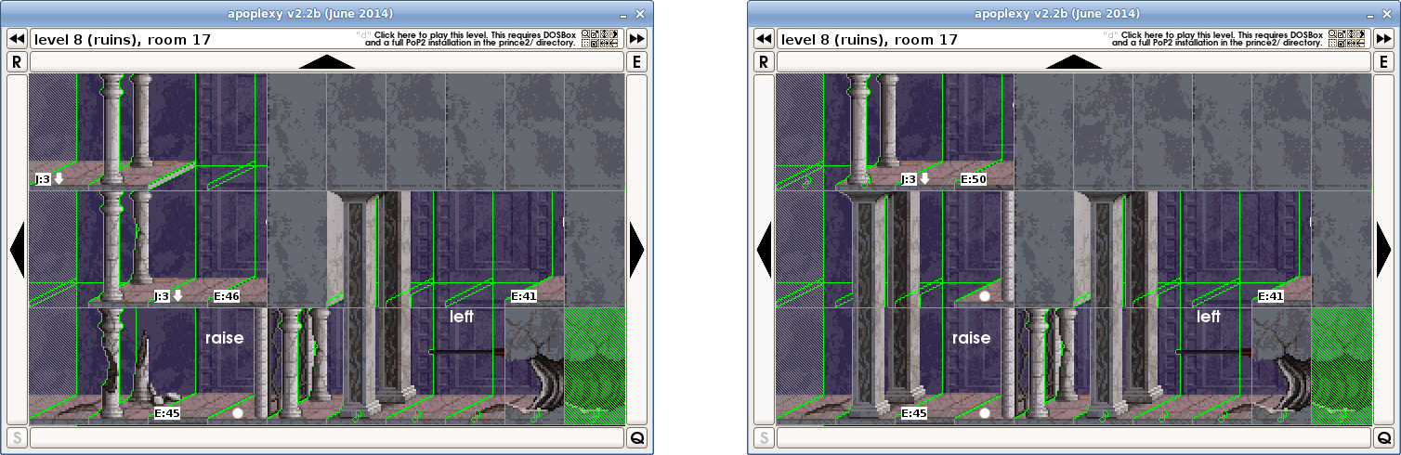

Room 18, tile 1: 20/0 0 10 1 -> 20/1 0 10 1 (different wall)
Room 18, tile 2: 20/0 0 9 0 -> 20/2 0 9 0 (different wall)
Room 18, tile 5: 20/0 0 9 1 -> 20/1 0 9 1 (different wall)
Room 18, tile 6: 20/1 0 9 0 -> 20/2 0 9 0 (different wall)
Room 18, tile 7: 20/0 0 9 1 -> 20/2 0 9 1 (different wall)
Room 18, tile 8: 20/0 0 9 0 -> 20/1 0 9 0 (different wall)
Room 18, tile 9: 20/0 0 9 1 -> 20/1 0 9 1 (different wall)
Room 18, tile 11: 20/0 0 0 0 -> 20/2 0 0 0 (different wall)
Room 18, tile 12: 20/0 0 9 0 -> 20/1 0 9 0 (different wall)
Room 18, tile 28: 10/87 0 9 0 -> 10/69 0 9 0 (life potion, same in apoplexy v2.2b)
Room 20, tile 1: 20/0 0 9 1 -> 20/5 5 9 1 (crack on wall added in 1.0)
Room 20, tile 2: 20/0 0 9 0 -> 20/2 7 9 0 (crack on wall added in 1.0)
Room 20, tile 3: 20/0 0 9 1 -> 20/1 0 9 1 (different wall)
Room 20, tile 4: 20/1 0 9 0 -> 20/2 0 9 0 (different wall)
Room 20, tile 5: 20/0 0 9 1 -> 20/4 0 9 1 (different wall)
Room 20, tile 6: 20/0 0 9 0 -> 20/1 0 9 0 (different wall)
Room 20, tile 7: 20/0 0 9 1 -> 20/2 0 9 1 (different wall)
Room 20, tile 8: 20/0 0 9 0 -> 20/1 0 9 0 (different wall)
Room 20, tile 9: 20/0 0 9 1 -> 20/1 0 9 1 (different wall)
Room 20, tile 12: 0/0 0 10 0 -> 0/0 0 9 0 (different background)
Room 20, tile 13: 0/0 0 10 1 -> 0/0 0 9 1 (different background)
Room 20, tile 23: 10/54 0 9 1 -> 10/58 0 9 1 (red potion, same in apoplexy v2.2b)
Room 20, tile 28: 20/0 0 9 0 -> 20/1 0 9 0 (different wall)
Room 20, tile 29: 20/0 0 9 1 -> 20/2 6 9 1 (crack on wall added in 1.0)
Room 22, tile 1: 20/0 0 9 1 -> 20/1 0 9 1 (different wall)
Room 22, tile 3: 20/0 0 9 1 -> 20/2 9 9 1 (crack on wall added in 1.0)
Room 22, tile 4: 20/0 0 9 0 -> 20/8 10 9 0 (crack on wall added in 1.0)
Room 22, tile 5: 20/0 0 9 1 -> 20/6 0 9 1 (different wall)
Room 22, tile 6: 20/0 0 9 0 -> 20/1 0 9 0 (different wall)
Room 22, tile 7: 20/0 0 9 1 -> 20/2 0 9 1 (different wall)
Room 22, tile 8: 20/0 0 9 0 -> 20/1 0 9 0 (different wall)
Room 22, tile 9: 20/0 0 9 1 -> 20/1 0 9 1 (different wall)
Room 22, tile 10: 1/0 0 9 0 -> 1/0 8 9 0 (crack on tile/wall added in 1.0)
Room 22, tile 21: 20/0 0 10 1 -> 20/1 0 10 1 (different wall)
Room 24, tile 23: 10/54 0 8 3 -> 10/41 0 8 3 (red potion, same in apoplexy v2.2b)
Room 25, tile 21: 10/176 0 10 1 -> 10/163 0 10 1 (purple potion, same in apoplexy v2.2b)
Event 46 changes room: 17, loc: 23. (t: 255, l: 253, r: 253) -> room: 1, loc: 23. (t: 255, l: 253, r: 253)
Event 50 changes room: 1, loc: 0. (t: 255, l: 255, r: 255) -> room: 17, loc: 23. (t: 0, l: 253, r: 253)
Prince starts in room: 16, position: 16, turned: r -> room: 16, position: 16, turned: l
Static guards in room 5: 1 -> 0
Static guard 1: 20|144|0|0|3|170|0|0|0|1|0|0|0|0|0|8|0|255|0|0|0|0|0 -> (none)
Static guards in room 10: 2 -> 3
Static guard 3: (none) -> 20|208|1|0|3|170|0|0|0|1|2|0|0|0|0|8|0|255|0|0|0|0|0

4.7 Level 9

Room 3, tile 17: 10/51 0 9 1 -> 10/39 0 9 1 (red potion, same in apoplexy v2.2b)
Room 4, tile 23: 10/33 0 9 1 -> 10/53 0 9 1 (red potion, same in apoplexy v2.2b)
Room 5, tile 22: 10/51 0 10 0 -> 10/40 0 10 0 (red potion, same in apoplexy v2.2b)
Room 7, tile 3: 10/56 0 9 1 -> 10/33 0 9 1 (red potion, same in apoplexy v2.2b)
Room 9, tile 22: 10/48 0 8 4 -> 10/37 0 8 4 (red potion, same in apoplexy v2.2b)
Room 13, tile 23: 10/81 0 0 0 -> 10/85 0 0 0 (life potion, same in apoplexy v2.2b)
Static guards in room 1: 1 -> 0
Static guard 1: 21|192|0|0|3|170|0|0|0|1|0|82|117|110|45|8|1|255|0|0|0|0|0 -> (none)
Static guards in room 5: 1 -> 2
Static guard 2: (none) -> 21|0|2|0|3|170|0|0|0|1|1|82|117|110|45|8|1|255|0|0|0|0|0
Static guards in room 12: 0 -> 1
Static guard 1: (none) -> 21|176|0|0|1|175|0|0|0|1|0|0|0|0|0|8|0|1|0|0|0|0|0
Static guards in room 13: 1 -> 0
Static guard 1: 21|240|1|0|1|175|0|0|0|1|0|0|0|0|0|8|0|1|0|0|0|0|0 -> (none)

4.8 Level 10

Room 1, tile 20: 19/0 0 8 0 -> 19/1 0 8 0 (flame, same in apoplexy v2.2b)
Room 1, tile 27: 19/2 0 8 0 -> 19/1 0 8 0 (flame, same in apoplexy v2.2b)
Room 2, tile 22: 19/3 0 8 0 -> 19/1 0 8 0 (flame, same in apoplexy v2.2b)
Room 2, tile 25: 19/2 0 20 1 -> 19/0 0 20 1 (flame, same in apoplexy v2.2b)
Room 4, tile 21: 19/1 0 9 0 -> 19/0 0 9 0 (flame, same in apoplexy v2.2b)
Room 5, tile 22: 19/1 0 16 0 -> 19/0 0 16 0 (flame, same in apoplexy v2.2b)
Room 5, tile 27: 10/49 0 9 0 -> 10/37 0 9 0 (red potion, same in apoplexy v2.2b)
Room 8, tile 16: 19/0 0 8 0 -> 19/2 0 8 0 (flame, same in apoplexy v2.2b)
Room 8, tile 18: 10/42 0 9 0 -> 10/41 0 9 0 (red potion, same in apoplexy v2.2b)
Room 9, tile 10: 19/3 0 9 0 -> 19/1 0 9 0 (flame, same in apoplexy v2.2b)
Room 9, tile 18: 19/2 0 8 0 -> 19/0 0 8 0 (flame, same in apoplexy v2.2b)
Room 10, tile 17: 19/3 0 8 0 -> 19/1 0 8 0 (flame, same in apoplexy v2.2b)
Room 12, tile 20: 19/3 0 8 0 -> 19/1 0 8 0 (flame, same in apoplexy v2.2b)
Room 12, tile 23: 19/1 0 0 0 -> 19/3 0 0 0 (flame, same in apoplexy v2.2b)
Room 12, tile 26: 19/2 0 9 0 -> 19/0 0 9 0 (flame, same in apoplexy v2.2b)
Room 13, tile 11: 19/2 0 9 0 -> 19/3 0 9 0 (flame, same in apoplexy v2.2b)
Room 13, tile 14: 19/3 0 9 0 -> 19/2 0 9 0 (flame, same in apoplexy v2.2b)
Room 15, tile 7: 10/53 0 9 0 -> 10/37 0 9 0 (red potion, same in apoplexy v2.2b)
Room 15, tile 20: 19/3 0 9 0 -> 19/1 0 9 0 (flame, same in apoplexy v2.2b)
Room 15, tile 26: 19/1 0 9 0 -> 19/2 0 9 0 (flame, same in apoplexy v2.2b)
Room 16, tile 28: 19/0 0 9 0 -> 19/2 0 9 0 (flame, same in apoplexy v2.2b)
Room 17, tile 2: 10/51 0 16 0 -> 10/42 0 16 0 (red potion, same in apoplexy v2.2b)
Room 18, tile 0: 19/2 0 9 0 -> 19/0 0 9 0 (flame, same in apoplexy v2.2b)
Room 18, tile 22: 19/3 0 7 0 -> 19/0 0 7 0 (flame, same in apoplexy v2.2b)
Room 18, tile 26: 19/3 0 9 0 -> 19/0 0 9 0 (flame, same in apoplexy v2.2b)
Room 18, tile 29: 19/3 0 8 0 -> 19/1 0 8 0 (flame, same in apoplexy v2.2b)
Room 19, tile 8: 4/0 0 16 0 -> 20/0 0 16 0 (changed a closed gate to a wall in 1.0; makes it more difficult)

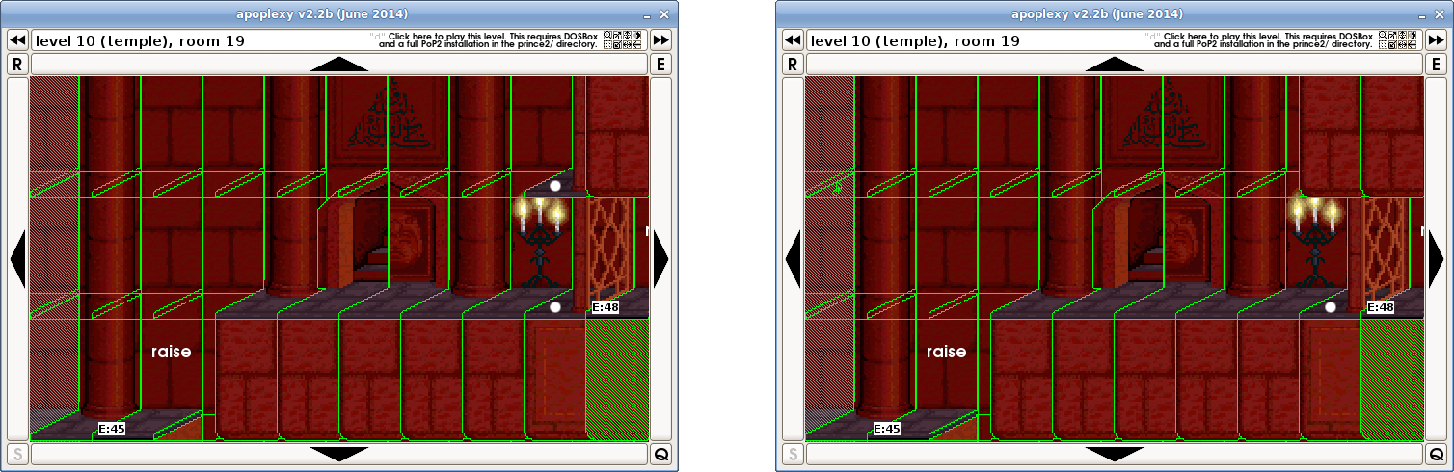

Room 19, tile 17: 19/2 0 8 0 -> 19/3 0 8 0 (flame, same in apoplexy v2.2b)
Room 20, tile 23: 19/2 0 9 0 -> 19/3 0 9 0 (flame, same in apoplexy v2.2b)
Room 20, tile 25: 19/2 0 9 0 -> 19/0 0 9 0 (flame, same in apoplexy v2.2b)
Room 20, tile 28: 10/43 0 8 0 -> 10/34 0 8 0 (red potion, same in apoplexy v2.2b)
Room 21, tile 7: 10/59 0 4 0 -> 10/44 0 4 0 (red potion, same in apoplexy v2.2b)
Room 21, tile 21: 19/3 0 8 0 -> 19/0 0 8 0 (flame, same in apoplexy v2.2b)
Room 23, tile 22: 19/3 0 9 0 -> 19/2 0 9 0 (flame, same in apoplexy v2.2b)
Room 23, tile 28: 19/0 0 9 0 -> 19/3 0 9 0 (flame, same in apoplexy v2.2b)
Room 24, tile 26: 10/44 0 9 0 -> 10/48 0 9 0 (red potion, same in apoplexy v2.2b)
Room 25, tile 27: 19/0 0 8 0 -> 19/1 0 8 0 (flame, same in apoplexy v2.2b)
Room 27, tile 27: 19/1 0 9 0 -> 19/0 0 9 0 (flame, same in apoplexy v2.2b)
Room 28, tile 11: 19/0 0 9 0 -> 19/1 0 9 0 (flame, same in apoplexy v2.2b)
Room 29, tile 23: 19/0 0 9 0 -> 19/2 0 9 0 (flame, same in apoplexy v2.2b)
Room 29, tile 26: 19/3 0 9 0 -> 19/2 0 9 0 (flame, same in apoplexy v2.2b)
Room 32, tile 7: 19/3 0 9 0 -> 19/1 0 9 0 (flame, same in apoplexy v2.2b)
Room 32, tile 16: 10/89 0 8 0 -> 10/90 0 8 0 (red potion, same in apoplexy v2.2b)

4.9 Level 11

Room 3, tile 27: 10/73 0 9 0 -> 10/68 0 9 0 (life potion, same in apoplexy v2.2b)
Room 5, tile 23: 19/2 0 9 0 -> 19/1 0 9 0 (flame, same in apoplexy v2.2b)
Room 5, tile 26: 19/3 0 9 0 -> 19/2 0 9 0 (flame, same in apoplexy v2.2b)
Room 6, tile 15: 19/0 0 9 0 -> 19/3 0 9 0 (flame, same in apoplexy v2.2b)
Room 10, tile 28: 19/3 0 9 0 -> 19/0 0 9 0 (flame, same in apoplexy v2.2b)
Room 12, tile 3: 19/1 0 9 0 -> 19/0 0 9 0 (flame, same in apoplexy v2.2b)
Room 13, tile 11: 10/37 0 9 0 -> 10/59 0 9 0 (red potion, same in apoplexy v2.2b)
Room 13, tile 12: 19/2 0 9 0 -> 19/1 0 9 0 (flame, same in apoplexy v2.2b)
Room 15, tile 24: 10/161 0 9 0 -> 10/169 0 9 0 (purple potion, same in apoplexy v2.2b)
Room 18, tile 28: 19/2 0 9 0 -> 19/0 0 9 0 (flame, same in apoplexy v2.2b)
Room 23, tile 13: 19/0 0 9 0 -> 19/2 0 9 0 (flame, same in apoplexy v2.2b)
Room 23, tile 16: 19/0 0 9 0 -> 19/3 0 9 0 (flame, same in apoplexy v2.2b)
Room 24, tile 23: 19/1 0 9 0 -> 19/3 0 9 0 (flame, same in apoplexy v2.2b)
Room 25, tile 19: 10/33 0 9 0 -> 10/59 0 9 0 (red potion, same in apoplexy v2.2b)

4.10 Level 12

Room 1, tile 0: 19/1 0 9 0 -> 19/2 0 9 0 (flame, same in apoplexy v2.2b)
Room 1, tile 2: 19/1 0 9 0 -> 1/0 0 8 0 (flame changed to tile in 1.0)
Room 1, tile 4: 19/1 0 9 0 -> 1/0 0 9 0 (flame changed to tile in 1.0)
Room 1, tile 6: 19/3 0 9 0 -> 1/0 0 8 0 (flame changed to tile in 1.0)
Room 1, tile 8: 19/1 0 9 0 -> 19/3 0 9 0 (flame, same in apoplexy v2.2b)
Room 2, tile 11: 10/57 0 9 0 -> 10/76 0 9 0 (red potion changed to life potion in 1.0; makes it easier)

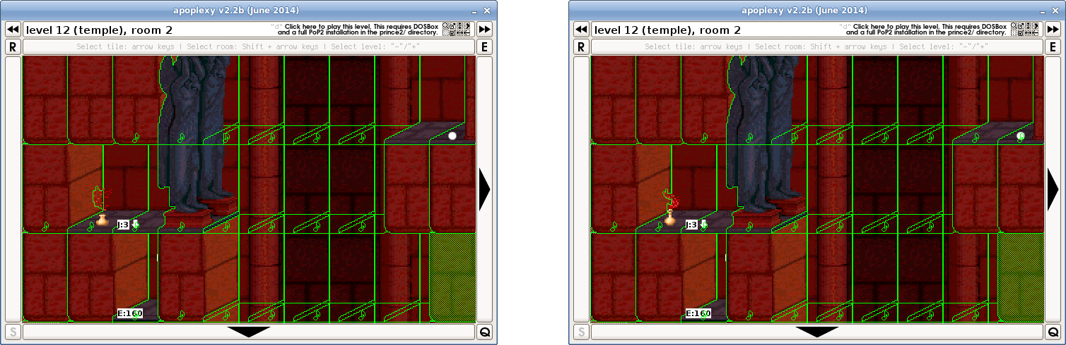

Room 5, tile 0: 4/0 0 14 0 -> 4/0 0 8 0 (different background)
Room 5, tile 7: 19/1 0 9 0 -> 1/0 0 8 0 (flame changed to tile in 1.0)
Room 5, tile 17: 19/3 0 9 0 -> 19/0 0 9 0 (flame, same in apoplexy v2.2b)
Room 6, tile 20: 19/3 0 11 0 -> 19/2 0 11 0 (flame, same in apoplexy v2.2b)
Room 6, tile 23: 19/3 0 8 0 -> 1/0 0 8 0 (flame changed to tile in 1.0)
Room 6, tile 25: 19/2 0 8 0 -> 1/0 0 8 0 (flame changed to tile in 1.0)
Room 8, tile 3: 19/0 0 9 0 -> 19/1 0 9 0 (flame, same in apoplexy v2.2b)
Room 8, tile 8: 19/2 0 9 0 -> 1/0 0 9 0 (flame changed to tile in 1.0)
Room 8, tile 28: 19/0 0 9 0 -> 1/0 0 8 0 (flame changed to tile in 1.0)
Room 9, tile 7: 19/3 0 9 0 -> 19/1 0 9 0 (flame, same in apoplexy v2.2b)
Room 10, tile 22: 19/2 0 9 0 -> 19/0 0 9 0 (flame, same in apoplexy v2.2b)
Room 12, tile 17: 19/3 0 9 0 -> 19/1 0 9 0 (flame, same in apoplexy v2.2b)
Room 14, tile 22: 19/3 0 9 0 -> 19/0 0 9 0 (flame, same in apoplexy v2.2b)
Room 14, tile 24: 19/1 0 9 0 -> 19/2 0 9 0 (flame, same in apoplexy v2.2b)
Room 17, tile 29: 10/44 0 11 0 -> 10/41 0 11 0 (red potion, same in apoplexy v2.2b)
Room 18, tile 4: 19/3 0 9 0 -> 19/2 0 9 0 (flame, same in apoplexy v2.2b)
Room 18, tile 5: 5/146 0 9 0 -> 1/0 0 9 0 (raise button changed to tile in 1.0)
Room 18, tile 22: 10/47 0 9 0 -> 10/57 0 9 0 (red potion, same in apoplexy v2.2b)
Room 18, tile 29: 20/0 0 0 0 -> 2/0 0 0 0 (wall changed to spike wall in 1.0; makes it more difficult in room 24)
Room 21, tile 26: 19/1 0 9 0 -> 19/2 0 9 0 (flame, same in apoplexy v2.2b)
Room 22, tile 23: 19/2 0 9 0 -> 19/0 0 9 0 (flame, same in apoplexy v2.2b)
Room 22, tile 28: 10/45 0 9 0 -> 10/36 0 9 0 (red potion, same in apoplexy v2.2b)
Room 23, tile 11: 0/0 0 18 0 -> 0/0 0 19 4 (different background)
Room 23, tile 12: 0/0 0 18 1 -> 0/0 0 19 5 (different background)
Room 23, tile 14: 0/0 0 9 0 -> 0/0 0 19 4 (different background)
Room 23, tile 15: 0/0 0 11 0 -> 0/0 0 19 5 (different background)
Room 23, tile 16: 0/0 0 19 4 -> 0/0 0 11 0 (different background)
Room 23, tile 17: 0/0 0 19 5 -> 0/0 0 9 0 (different background)
Room 23, tile 21: 16/0 0 9 0 -> 1/0 0 19 0 (left level door changed to tile in 1.0)
Room 23, tile 22: 17/0 0 9 0 -> 10/37 0 19 1 (right level door changed to red potion in 1.0)
Room 23, tile 24: 10/211 0 9 0 -> 10/217 0 19 0 (green potion, same in apoplexy v2.2b)
Room 23, tile 25: 19/3 0 9 0 -> 1/0 0 19 1 (flame changed to tile in 1.0)
Room 23, tile 26: 1/0 0 19 0 -> 19/1 0 9 0 (tile changed to flame in 1.0)
Room 23, tile 27: 1/0 0 19 1 -> 10/178 0 9 0 (tile changed to purple potion in 1.0)

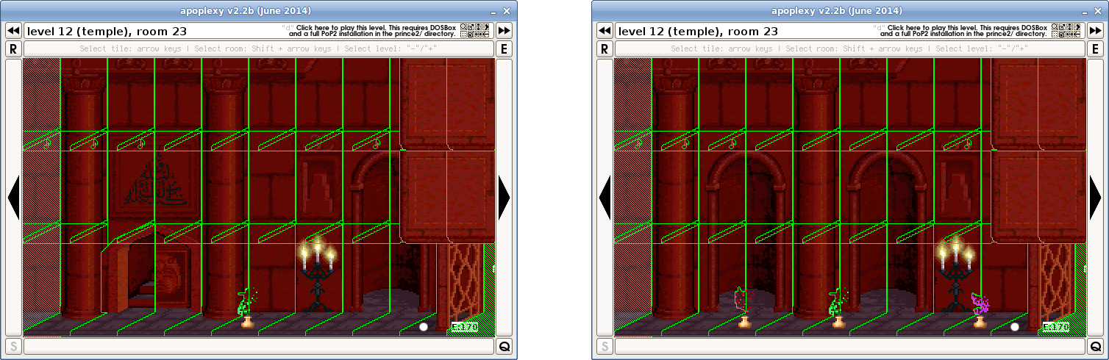

Room 24, tile 20: 10/55 0 8 0 -> 1/0 0 8 0 (red potion changed to tile in 1.0)
Room 24, tile 21: 19/2 0 9 0 -> 19/0 0 9 0 (flame, same in apoplexy v2.2b)
Room 24, tile 22: 1/0 0 19 0 -> 6/175 0 19 0 (tile changed to drop tile in 1.0; makes it more difficult)
Room 24, tile 25: 1/0 0 9 0 -> 10/167 0 9 0 (tile changed to purple potion in 1.0; makes it more difficult)
Room 24, tile 27: 1/0 0 19 1 -> 10/174 0 19 1 (tile changed to purple potion in 1.0; makes it more difficult)
Room 24, tile 28: 19/2 0 9 0 -> 19/0 0 9 0 (flame, same in apoplexy v2.2b)

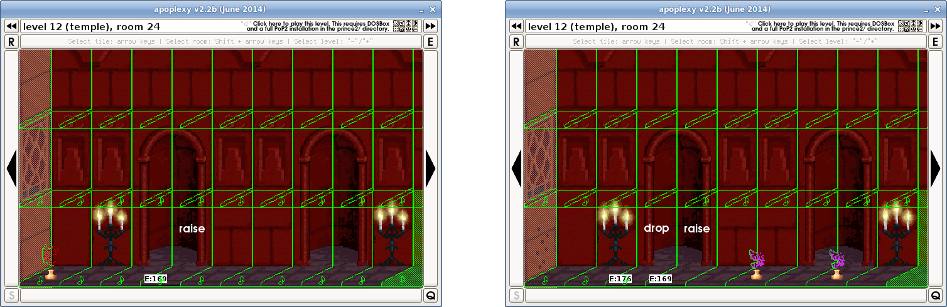

Room 25, tile 21: 19/0 0 9 0 -> 19/2 0 9 0 (flame, same in apoplexy v2.2b)
Room 25, tile 25: 19/1 0 9 0 -> 19/0 0 9 0 (flame, same in apoplexy v2.2b)
Room 25, tile 28: 19/1 0 9 0 -> 19/3 0 9 0 (flame, same in apoplexy v2.2b)
Event 145 changes room: 12, loc: 21. (t: 0, l: 253, r: 167) -> room: 18, loc: 19. (t: 0, l: 253, r: 176)
Event 147 changes room: 12, loc: 21. (t: 0, l: 253, r: 253) -> room: 1, loc: 21. (t: 0, l: 253, r: 253)
Event 168 changes room: 18, loc: 19. (t: 255, l: 144, r: 253) -> room: 1, loc: 19. (t: 255, l: 253, r: 253)
Event 169 changes room: 18, loc: 19. (t: 0, l: 253, r: 253) -> room: 7, loc: 23. (t: 0, l: 253, r: 253)
Event 170 changes room: 7, loc: 23. (t: 0, l: 253, r: 170) -> room: 18, loc: 19. (t: 0, l: 253, r: 253)
Event 171 changes room: 23, loc: 22. (t: 255, l: 169, r: 253) -> room: 1, loc: 23. (t: 255, l: 253, r: 253)
Event 172 changes room: 1, loc: 0. (t: 255, l: 255, r: 255) -> room: 1, loc: 19. (t: 0, l: 253, r: 253)
Event 173 changes room: 1, loc: 0. (t: 255, l: 255, r: 255) -> room: 1, loc: 19. (t: 255, l: 253, r: 253)
Event 174 changes room: 1, loc: 0. (t: 255, l: 255, r: 255) -> room: 1, loc: 19. (t: 0, l: 253, r: 253)
Event 175 changes room: 1, loc: 0. (t: 255, l: 255, r: 255) -> room: 1, loc: 19. (t: 0, l: 253, r: 253)
Event 176 changes room: 1, loc: 0. (t: 255, l: 255, r: 255) -> room: 18, loc: 19. (t: 0, l: 253, r: 253)
Event 177 changes room: 1, loc: 0. (t: 255, l: 255, r: 255) -> room: 12, loc: 21. (t: 255, l: 144, r: 253)
Prince starts in room: 19, position: 23, turned: r -> room: 19, position: 23, turned: l
Static guards in room 9: 0 -> 1
Static guard 1: (none) -> 1|192|0|0|1|77|0|0|0|1|0|0|0|0|0|7|6|0|0|0|0|0|0
Static guards in room 10: 1 -> 0
Static guard 1: 1|0|2|0|1|77|0|0|0|1|0|0|0|0|0|7|6|0|0|0|0|0|0 -> (none)

4.11 Level 13

Room 1, tile 2: 19/0 0 9 0 -> 19/2 0 9 0 (flame, same in apoplexy v2.2b)
Room 2, tile 19: 19/1 192 9 0 -> 19/2 192 9 0 (flame, same in apoplexy v2.2b)
Room 3, tile 11: 19/2 0 9 0 -> 19/3 0 9 0 (flame, same in apoplexy v2.2b)
Room 3, tile 16: 19/3 0 18 0 -> 19/2 0 18 0 (flame, same in apoplexy v2.2b)
Room 6, tile 27: 19/3 0 9 0 -> 19/2 0 9 0 (flame, same in apoplexy v2.2b)
Room 6, tile 28: 10/47 0 9 0 -> 10/52 0 9 0 (red potion, same in apoplexy v2.2b)
Room 8, tile 11: 19/3 0 0 0 -> 19/0 0 0 0 (flame, same in apoplexy v2.2b)
Room 9, tile 10: 19/3 0 9 0 -> 19/2 0 9 0 (flame, same in apoplexy v2.2b)
Room 9, tile 15: 19/2 0 9 0 -> 19/3 0 9 0 (flame, same in apoplexy v2.2b)
Room 10, tile 13: 19/0 0 9 0 -> 19/2 0 9 0 (flame, same in apoplexy v2.2b)
Room 10, tile 18: 19/0 0 9 0 -> 19/1 0 9 0 (flame, same in apoplexy v2.2b)
Room 11, tile 13: 19/0 0 9 0 -> 19/1 0 9 0 (flame, same in apoplexy v2.2b)
Room 11, tile 17: 19/0 0 9 0 -> 19/3 0 9 0 (flame, same in apoplexy v2.2b)
Room 13, tile 16: 19/0 0 10 0 -> 19/3 0 10 0 (flame, same in apoplexy v2.2b)
Room 13, tile 18: 19/3 0 9 0 -> 19/1 0 9 0 (flame, same in apoplexy v2.2b)
Room 17, tile 22: 19/0 0 9 0 -> 19/2 0 9 0 (flame, same in apoplexy v2.2b)
Room 18, tile 4: 10/103 0 9 0 -> 10/105 0 9 0 (float potion, same in apoplexy v2.2b)
Room 18, tile 6: 25/0 0 9 0 -> 20/0 0 9 0 (crushing wall changed to wall in 1.0; makes it easier)

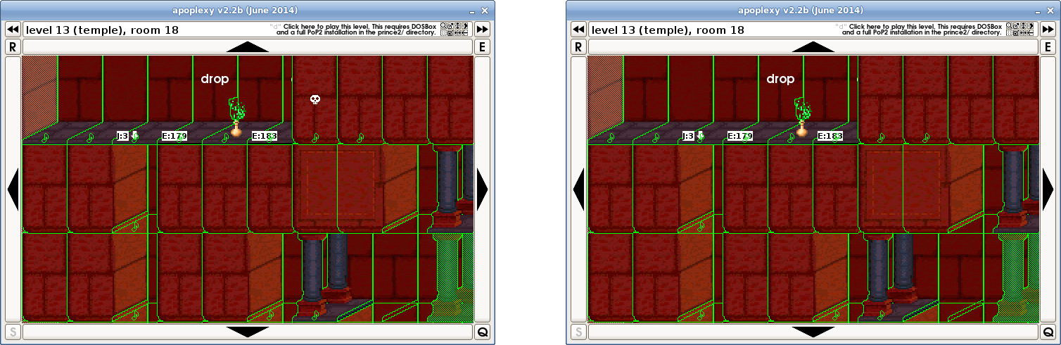

Room 25, tile 23: 10/54 0 15 0 -> 10/40 0 15 0 (red potion, same in apoplexy v2.2b)
Room 28, tile 10: 19/3 0 9 0 -> 19/2 0 9 0 (flame, same in apoplexy v2.2b)
Room 28, tile 13: 19/0 0 9 0 -> 19/1 0 9 0 (flame, same in apoplexy v2.2b)
Room 28, tile 18: 19/0 0 9 0 -> 1/0 0 9 0 (flame changed to tile in 1.0)
Room 29, tile 10: 19/0 0 9 0 -> 19/3 0 9 0 (flame, same in apoplexy v2.2b)
Room 29, tile 13: 19/1 0 4 0 -> 1/0 0 8 0 (flame changed to tile in 1.0)
Room 29, tile 15: 19/2 0 9 0 -> 1/0 0 9 0 (flame changed to tile in 1.0)
Room 29, tile 16: 10/71 0 9 0 -> 10/77 0 9 0 (life potion, same in apoplexy v2.2b)
Room 29, tile 18: 19/2 0 9 0 -> 19/0 0 9 0 (flame, same in apoplexy v2.2b)
Room 30, tile 19: 10/51 0 9 0 -> 10/47 0 9 0 (red potion, same in apoplexy v2.2b)
Room 31, tile 10: 10/34 0 9 0 -> 10/45 0 9 0 (red potion, same in apoplexy v2.2b)
Room 32, tile 17: 19/3 0 9 0 -> 19/0 0 9 0 (flame, same in apoplexy v2.2b)
Event 179 changes room: 18, loc: 6. (t: 0, l: 253, r: 253) -> room: 1, loc: 6. (t: 0, l: 253, r: 253)
Event 180 changes room: 18, loc: 6. (t: 0, l: 253, r: 253) -> room: 1, loc: 6. (t: 0, l: 253, r: 253)
Event 183 changes room: 18, loc: 6. (t: 0, l: 253, r: 253) -> room: 1, loc: 6. (t: 0, l: 253, r: 253)

4.12 Level 14

Room 2, tile 3: 1/0 0 9 0 -> 1/0 192 9 0 (different background?)
Room 2, tile 4: 1/0 0 9 1 -> 1/0 192 9 1 (different background?)
Room 2, tile 5: 1/0 0 9 0 -> 1/0 192 9 0 (different background?)
Room 2, tile 19: 1/0 192 9 0 -> 0/0 192 9 0 (tile removed in 1.0)
Room 7, tile 1: 1/0 192 0 0 -> 10/57 0 0 0 (tile changed to red potion in 1.0; makes it easier)
Room 7, tile 10: 0/144 17 0 0 -> 0/208 17 0 0 (different background?)
Room 7, tile 11: 0/113 18 0 0 -> 0/129 16 0 0 (different background?)
Room 7, tile 12: 1/50 16 0 0 -> 1/162 17 0 0 (different background?)
Room 7, tile 13: 1/131 16 0 0 -> 1/83 16 0 0 (different background?)
Room 7, tile 14: 1/196 16 0 0 -> 1/148 17 0 0 (different background?)
Room 7, tile 23: 0/117 16 0 0 -> 0/53 17 0 0 (different background?)
Room 7, tile 24: 1/0 192 0 0 -> 10/48 0 0 0 (tile changed to red potion in 1.0; makes it easier)
Room 8, tile 10: 1/156 16 0 0 -> 1/182 16 0 0 (different background?)
Room 8, tile 18: 1/0 192 0 0 -> 10/34 0 0 0 (tile changed to red potion in 1.0; makes it easier)
Room 8, tile 20: 0/109 18 0 0 -> 0/119 16 0 0 (different background?)
Room 8, tile 26: 1/62 17 0 0 -> 1/72 18 0 0 (different background?)
Room 8, tile 28: 1/0 192 0 0 -> 10/56 0 0 0 (tile changed to red potion in 1.0; makes it easier)

4.13 Level 22

Room 11, tile 4: 21/0 0 9 0 -> 1/3 0 9 0 (skeleton changed to tile in 1.0)
Room 11, tile 5: 1/1 0 9 1 -> 1/0 0 9 1 (crack on tile removed in 1.0)
Room 11, tile 13: 20/2 0 9 1 -> 20/0 0 9 1 (different wall)
Room 11, tile 14: 20/0 0 0 0 -> 21/0 0 9 0 (wall changed to skeleton in 1.0)
Room 11, tile 15: 20/1 0 9 0 -> 14/16 0 9 1 (wall changed to tile with rocks in 1.0)
Room 11, tile 16: 20/1 0 10 0 -> 3/1 0 10 0 (wall changed to broken pillar in 1.0)
Room 11, tile 17: 1/0 0 10 1 -> 14/32 0 10 1 (tile changed to tile with rocks in 1.0)
Room 11, tile 19: 1/0 0 9 1 -> 1/1 0 9 1 (crack on tile added in 1.0)
Room 20, tile 23: 10/57 0 9 1 -> 10/54 0 9 1 (red potion, same in apoplexy v2.2b)
Prince starts in room: 16, position: 16, turned: r -> room: 11, position: 4, turned: l
Static guards in room 11: 1 -> 0
Static guard 1: 3|242|0|255|3|130|0|0|0|1|0|0|0|0|0|5|6|0|0|0|0|0|0 -> (none)
Static guards in room 20: 1 -> 2
Static guard 2: (none) -> 20|144|0|0|1|170|0|0|0|1|1|0|0|0|0|8|0|255|0|0|0|0|0
Static guards in room 22: 2 -> 1
Static guard 2: 20|208|1|0|1|170|0|0|0|1|1|0|0|0|0|8|0|255|0|0|0|0|0 -> (none)

Credits

June 7, 2014: Initial version, by Norbert

http://forum.princed.org/viewtopic.php?f=70&t=3365
http://cid-19373c156095469b.office.live.com/self.aspx/PoP%5E_TUC/PoP%5E_TUC%5E_1.3.exe
http://forum.princed.org/viewtopic.php?f=64&t=3487

