Prince of Persia 1 Special Events
a must-read for amateur mod creators

July 14, 2012

Contents

Preamble 2
License 2
1. Level 1 3
1.1 Falling Entry 3
1.2 Tile Activation 4
2. Level 3 5
2.1 Checkpoint 5
2.2 Skeleton 7
3. Level 4 9
4. Level 5 10
5. Level 6 11
6. Level 7 12
7. Level 8 13
8. Level 12a (12) 14
8.1 Tile Change 14
8.2 Shadow Appears 15
8.3 Tiles Appear 16
8.4 Next Section 17
9. Level 12b (13) 18
9.1 Falling Tiles 18
9.2 Jaffar's Death 19
10. Final Level 21
11. Potions Level 22
12. Demo Level 23
Afterword 24
Credits 24

Preamble

This document describes all the special events that take place in Prince of Persia 1, when they are triggered and at what locations. It is possible to customize these events with, for example, CusPop, by altering the PRINCE.EXE file. This document describes the characteristics of the events when aforementioned file has not been changed. This knowledge can be used to change levels in such a way that the events still take place, but with different results or at (seemingly) different locations.

This is only the second version of this document, so there is still room for improvement. In case you find a mistake or have a suggestion, please let us know.

License

Copyright © 2012 Prince of Persia modding community

Permission is granted to copy, distribute and/or modify this document under the terms of the GNU Free Documentation License, Version 1.3 or any later version published by the Free Software Foundation; with no Invariant Sections, no Front-Cover Texts, and no Back-Cover Texts.

1. Level 1

1.1 Falling Entry

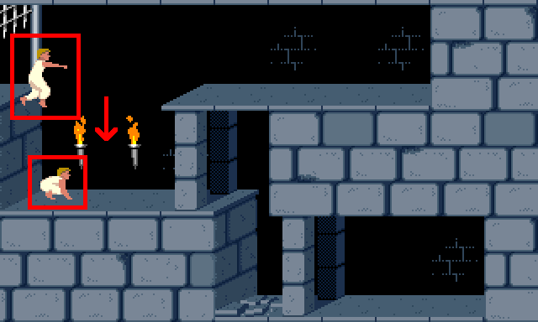
The player makes a falling entry and starts without his sword. The first time the player crouches, a tune is played. In this context, the (painful) two-story drops do not count as crouching.

1.2 Tile Activation

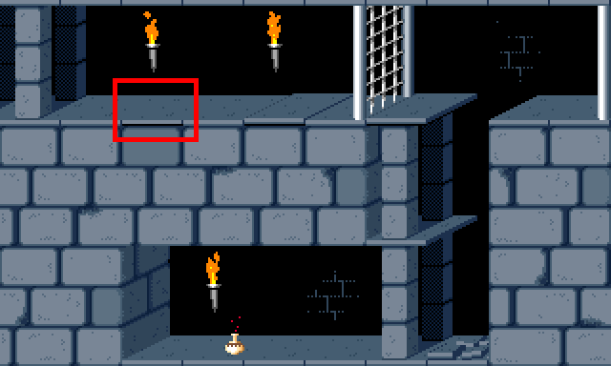
When level 1 begins, in room 5, the 3rd tile from the upper left is automatically being activated. The result of that trigger depends on the tile. A spike will come out, then go back. A closed gate will open. An open gate will soon close. Drop and raise tiles are being pushed. A loose tile will drop. A chomper will chomp once (or more, if the player is near the chomper). An exit door will open (if the player is not in room 5).

2. Level 3

2.1 Checkpoint

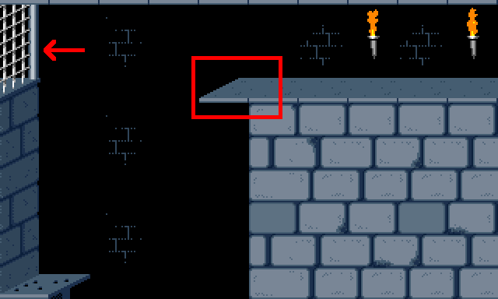
Level 3 has a checkpoint. If the player dies after having reached this point, he or she will respawn - come back to life - at the checkpoint and doesn't have to restart the level. The checkpoint is being activated when the player leaves room 7 to the left.

When the player dies and respawns at the checkpoint, the game will automatically remove the 5th tile from the upper left in room 7.

The closing sound of gates in room 2 can be heard from all rooms, regardless their locations within that room.

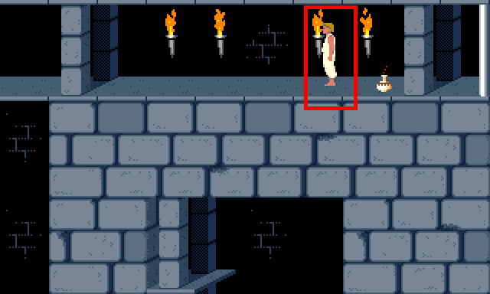
A player that dies after having reached the checkpoint, will respawn in room 2, on the 4th tile from the upper right, facing left.

2.2 Skeleton

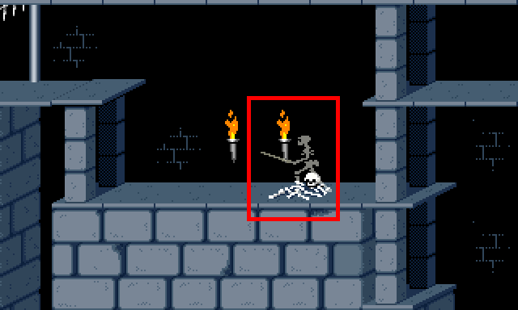
In level 3, if the level exit door has been raised, a skeleton will come alive if the player touches the 4th tile from the left, in any row. This only happens to the skeleton that is in room 1, in the middle row, on the 5th tile from the right.

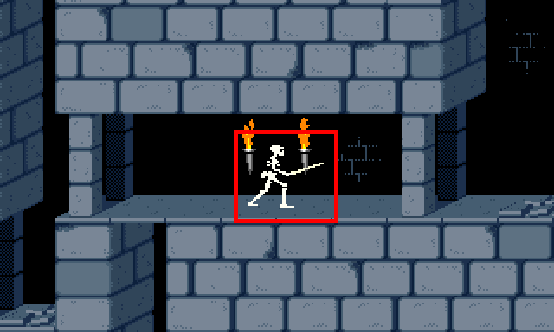
If the skeleton falls off room 1, it will reappear in room 3, in the middle row, on the 5th tile from the left, facing right, but only if room 3 is below room 1.

3. Level 4

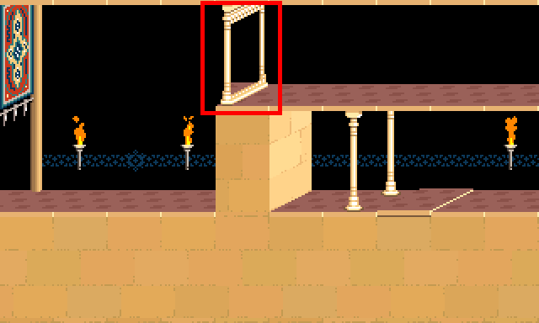
In level 4, if the level exit door has been fully raised, a mirror will be placed. This mirror actually becomes visible when the player reenters room 4 or when the player moves onto the mirror's location. The mirror's location is in aforementioned room, on the 5th tile from the top left. A tune is played when the player reenters the room, and a different tune than usual is played when the player exits the level.

4. Level 5

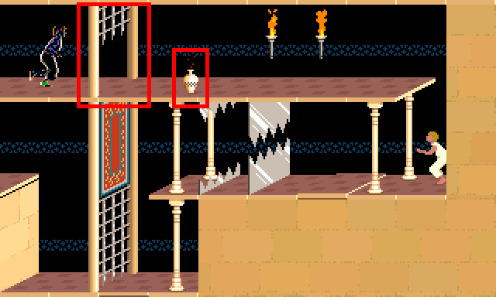
In level 5, the shadow drinks a potion if certain conditions are met. There has to be an open gate in room 24, on the 2nd tile from the upper left. (It may be closed at first and opened later.) Also, a potion - it doesn't matter which one - has to be in the same room, on the 4th tile from the upper left. The shadow will drink whatever potion is in aforementioned room on the 4th or 3rd tile from the upper left, provided that he can in fact reach the potion.

5. Level 6

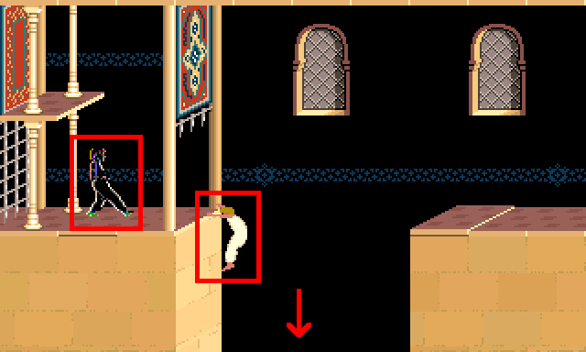
In level 6, the shadow will appear in room 1, in the middle row, on the right side of the 1st tile from the left, facing right. The shadow will usually step forward after the player has almost completed a four-tile jump. If there is a potion or sword on the 2nd tile from the left in the middle row, the shadow will crouch forward. The player's four-tile jump can be in any row and should end on one of the first five tiles from the left. This event will trigger no matter what tiles are being used in the room.

A tune is played when the player first enters room 1. Exiting that room at the bottom starts level 7, regardless what room - if any - is below it.

6. Level 7

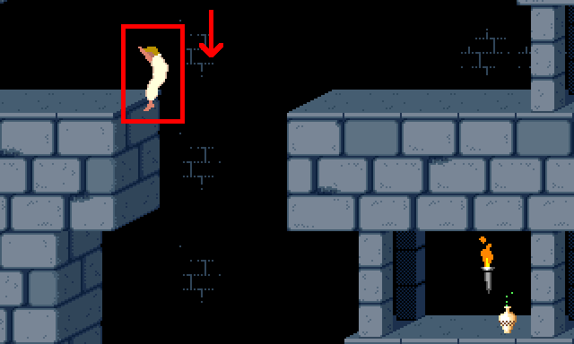
The player makes a falling entry. This only works if the player starts in room 17, in the bottom row. If the player starts in room 17, but not in the bottom row, an integer overflow will occur.

7. Level 8

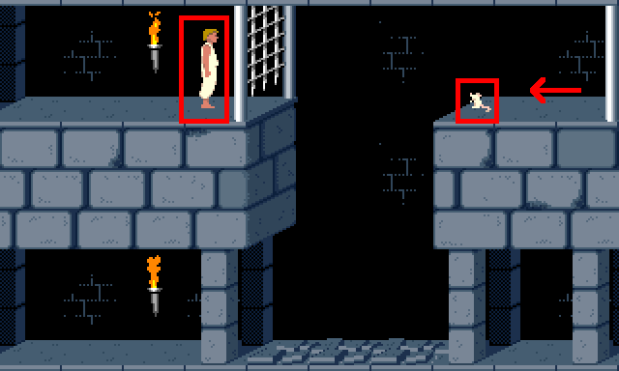
In level 8, if the level exit door has been raised, a mouse will appear in room 16. The mouse will only appear if the player has been in aforementioned room a total of 12.5 seconds. (So, it does not have to be continuous.) The mouse will move from the top right towards the 3rd tile from the top right and then back.

8. Level 12a (12)

8.1 Tile Change

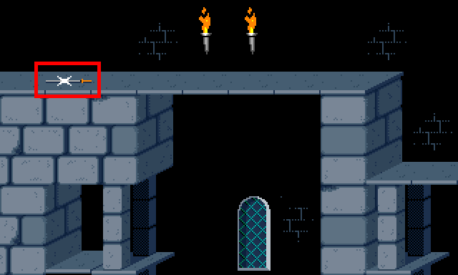
A tile in room 15 of level 12a (12) changes into a regular platform when the player leaves room 18 to the right. The tile in question is the 2nd tile from the top left.

8.2 Shadow Appears

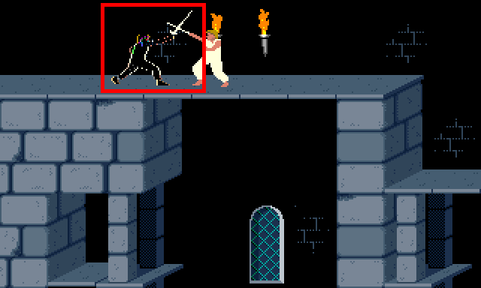
The shadow appears to fight the player in room 15. This only happens if there is no sword on the 2nd tile from the top left. The shadow appears when the player first walks on any of the six tiles from the left, regardless what row.

8.3 Tiles Appear

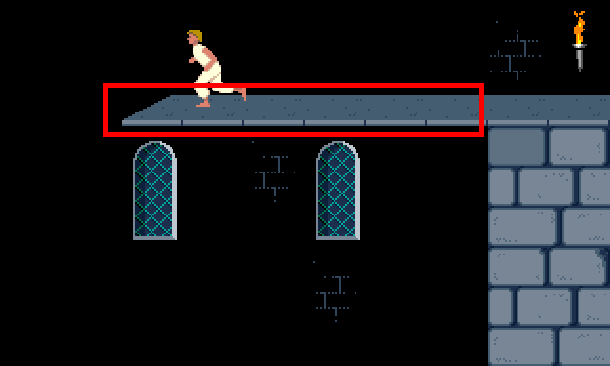
After the player has merged with the shadow, several tiles appear out of thin air. This happens when the player steps on any type of empty location: in room 2, the entire top row; in room 13, the four top right tiles.

8.4 Next Section

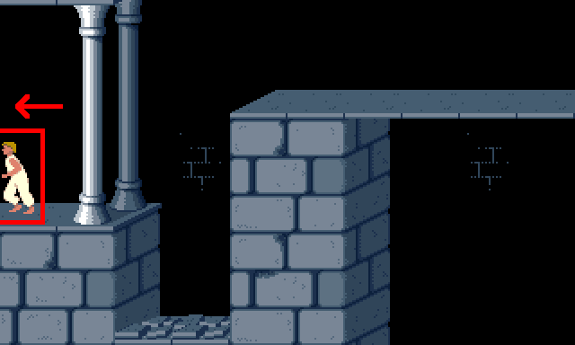
As soon as the player moves to room 23 from any other room, level 12b (13) will start.

9. Level 12b (13)

9.1 Falling Tiles

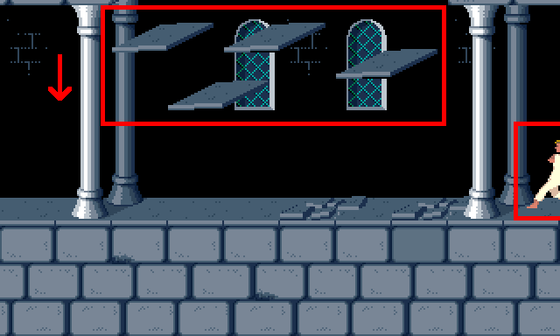
In level 12b (13), the six middle tiles above rooms 16 and 23 will fall down when the player enters these rooms. This only happens if they are loose tiles. The loose tiles do not shake if the player jumps in that row. If one or more of these tiles are gates, they are being opened instantly.

The player makes a one-tile running entry towards the location he or she is facing, provided that it's not a falling start.

9.2 Jaffar's Death

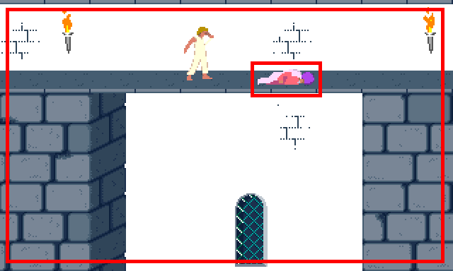
The screen flashes when Jaffar dies. That is, several times, all black pixels temporarily become white.

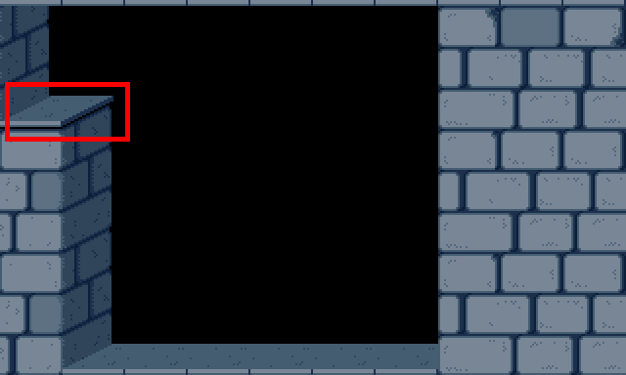
After Jaffar has died, entering any room from the right will activate the top left tile in room 24.

10. Final Level

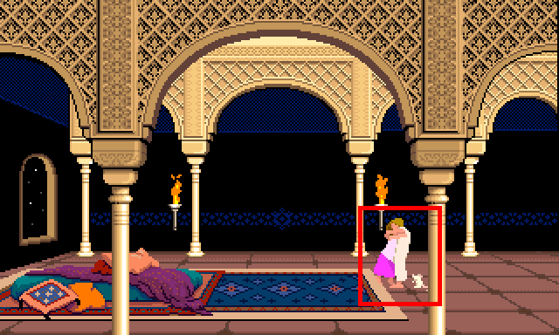
The game ends after the player moves to room 5 from any other room, or if the player starts in aforementioned room.

11. Potions Level

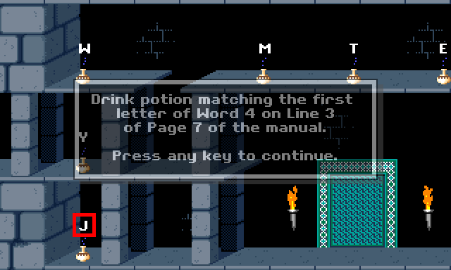
Letters appear. One of the potions is automatically being changed into a special blue potion that activates the upper left tile in room 8. Each regular blue potions takes half of the player's total hitpoints instead of just one hitpoint.

12. Demo Level

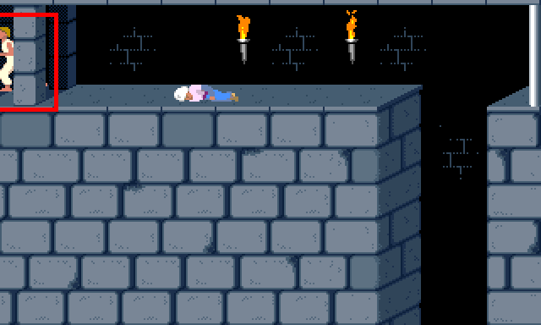
The demo ends when the player (dies or) enters room 24 from any direction.

Afterword

If you have any suggestions to further improve this document, please let us know in this forum thread: http://forum.princed.org/viewtopic.php?f=73&t=3151

Credits

July 12, 2012: | Initial version, by Norbert.
July 14, 2012: | Updated by Norbert, to include several additions and corrections by David from the Princed Forum.

http://www.popot.org/other_useful_tools.php?tool=CusPop_and_CusAsm
http://forum.princed.org/viewtopic.php?f=73&t=3151
http://www.popot.org/documentation.php?doc=OverflowBug
If the tile is not a button but its modifier refers to a door event that triggers a level door, then the level door will open.

